Section I: Scenario Demographics

Scenario Title: | Basic polytrauma for trauma team communication
Date of Development: | (01/05/2018)
Target Learning Group: | Juniors (PGY 1 – 2) Seniors (PGY ≥ 3) All Groups

Section II: Scenario Developers

Scenario Developer(s): | Dr. Chris Heyd
Affiliations/Institution(s): | McMaster University
Contact E-mail (optional): | christopher.heyd@medportal.ca / @cgheyd

Section III: Curriculum Integration

Learning Goals & Objectives
Educational Goal: | To challenge learners’ teamwork and communication skills through the stabilization of an unstable trauma patient
CRM Objectives: | - To practice effective leadership and followership in a clinical team  - To use best practices in team communication, including closed loop communication and periodic summaries  - To perform critical procedures during a resuscitation without losing situational awareness
Medical Objectives: | - To recognize respiratory failure in a blunt trauma patient and initiate simultaneous treatment and diagnostics  - To safely intubate an unstable trauma patient  - To identify and expediently treat a large hemothorax  - To identify and treat decompensated hemorrhagic shock

Case Summary: Brief Summary of Case Progression and Major Events
A 64-year old man is involved in a high-speed car crash. The trauma team is activated and he is brought directly to the ED. On arrival, he is hypoxic, tachycardic and altered. CXR reveals multiple rib fractures with a right-sided hemopneumothorax.

The team leader will need to effectively communicate with the team to ensure the tasks of intubation, chest tube placement and blood product administration are performed in a safe and quickly. The patient will stabilize after these treatments.

Members of the trauma team will have a staggered entry into the room. The team leader will need to balance communication with the new team members and the urgent interventions needed by the patient.

References
Marx JA, Hockberger RS, Walls RM, & Adams J. (2013). Rosen's emergency medicine: Concepts and clinical practice. St. Louis: Mosby.
Gillman LM, Widder S, Blaivas M & Karakitsos D. (2016). Trauma team dynamics: A trauma crisis resource management manual. Switzerland: Springer.

Section IV: Scenario Script

A. Scenario Cast & Realism
Patient: | Computerized Mannequin |  |  |  |  | Realism:  Select most important dimension(s) |  |  | Conceptual
 | Mannequin |  |  |  |  |  |  |  | Physical
 | Standardized Patient |  |  |  |  |  |  |  | Emotional/Experiential
 | Hybrid |  |  |  |  |  |  |  | Other: Interprofessional
 | Task Trainer |  |  |  |  |  |  |  | N/A
Confederates | Brief Description of Role
Bedside RN | To prompt team to clinical status, as required
B. Required Monitors
EKG Leads/Wires |  |  | Temperature Probe |  |  |  | Central Venous Line
NIBP Cuff |  |  | Defibrillator Pads |  |  |  | Capnography
Pulse Oximeter |  |  | Arterial Line |  |  |  | Other:
C. Required Equipment
Gloves |  |  | Nasal Prongs |  |  |  | Scalpel
Stethoscope |  |  | Venturi Mask |  |  |  | Tube Thoracostomy Kit
Defibrillator |  |  | Non-Rebreather Mask |  |  |  | Cricothyroidotomy Kit
IV Bags/Lines |  |  | Bag Valve Mask |  |  |  | Thoracotomy Kit
IV Push Medications |  |  | Laryngoscope |  |  |  | Central Line Kit
PO Tabs |  |  | Video Assisted Laryngoscope |  |  |  | Arterial Line Kit
Blood Products |  |  | ET Tubes |  |  |  | Other: C-Collar
Intraosseous Set-up |  |  | LMA |  |  |  | Other:
D. Moulage
Bruising to the right side of the thorax

E. Approximate Timing
Set-Up: |  | Variable for in situ |  | Scenario: | 10 min |  |  | Debriefing: |  | 10 min

Section V: Patient Data and Baseline State

A. Clinical Vignette: To Read Aloud at Beginning of Case
To be read aloud by simulation facilitator at start of case: “You are working as an Emergency physician at a tertiary care trauma center and have been called overhead to your trauma bay. A paramedic team has just arrived with a 64-year old trauma patient. He was involved in a highway speed head-on MVC. He was restrained and air bags deployed. He was the driver and the other drive died on scene. There were no other passengers. EMS extricated the patient easily. They have placed one IV line and started running normal saline. He has been placed on a non-rebreather mask but has remained tachycardic, hypoxic and altered. GCS has been consistently 14. The trauma team was activated based on injury mechanism but so far only the orthopedic resident has arrived at the bedside.”
B. Patient Profile and History
Patient Name: Paulo Matos |  |  |  |  |  | Age: 64 |  |  |  |  |  |  |  | Weight: 80 kg
Gender: M F |  |  |  |  |  | Code Status: Unknown
Chief Complaint: Blunt polytrauma
History of Presenting Illness: High-speed MVC, head-on collision, restrained + airbags
Past Medical History: |  | Hypertension |  |  |  |  | Medications: |  |  |  |  | Hydrochlorothiazide
 |  | Dyslipidemia |  |  |  |  |  |  |  |  |  | Ramipril
 |  |  |  |  |  |  |  |  |  |  |  | Atorvastatin
Allergies: None
Social History: Retired steel factory foreman
Family History: Unremarkable
Review of Systems: |  | CNS: |  |  | Amnestic to event, mild confusion
 |  | HEENT: |  |  | Nil
 |  | CVS: |  |  | Sharp chest pain, pleuritic
 |  | RESP: |  |  | Short of breath
 |  | GI: |  |  | Nil
 |  | GU: |  |  | Nil
 |  | MSK: |  |  | Nil |  |  |  |  |  |  |  | INT: |  | Nil
C. Baseline Simulator State and Physical Exam
No Monitor Display |  |  |  | Monitor On, no data displayed |  |  |  |  |  |  | Monitor on Standard Display
HR: 120/min |  |  | BP: 100/65 |  |  |  |  | RR: 28/min |  |  |  |  |  |  | O₂SAT: 92% (NRB)
Rhythm: Sinus tach |  |  | T: 36.5ºC |  |  |  |  | Glucose: 6.5 mmol/L |  |  |  |  |  |  | GCS: 14 (E4 V4 M6)
General Status: Tachycardic, tachypneic, hypoxic, confused
CNS: | Awake, alert, confused, amnestic. PERL, moving all limbs, complaining of chest pain
HEENT: | Unremarkable
CVS: | Tachycardic, heart sounds normal
RESP: | Tachypneic, decreased breath sounds on Right side, crepitus
ABDO: | Soft, non-tender, non-distended
GU: | Unremarkable
MSK: | Right chest tenderness+crepitus  No long bone deformity, pelvis stable |  |  |  |  |  |  |  | SKIN: | Right chest bruising

Section VI: Scenario Progression

Scenario States, Modifiers and Triggers
Patient State | Patient Status | Learner Actions, Modifiers & Triggers to Move to Next State
1. Baseline State  Rhythm: Sinus tach  HR: 120/min  BP: 110/65  RR: 28/min  O₂SAT: 92% (NRB)  T: 36.6ºC | Confused, complains of chest pain | Learner Actions  - Place on monitors  - Listen to EMS  - Place 2nd IV line + BW  - Start crystalloid  - Call for blood products  - Primary survey  - FAST  - Provide analgesia  - Call for portable CXR, PXR  - Cap glucose | Modifiers  Changes to patient condition based on learner action  - EMS handover finishes Charting RN enters  Triggers  For progression to next state  - All actions complete or 5 min into case 2. Hypoxia
2. Hypoxia  Rhythm: Sinus tach  HR: 125/min  BP: 110/65  RR: 28/min  O₂SAT: 86% (NRB) | Becoming agitated | Learner Actions  - Communicate situation to anesthesia  - Prepare for intubation  - Prepare for chest tube | Modifiers  - Start of state Anesthesia enters  - Attempt chest tube placement patient becomes agitated  Triggers  - Intubation 3. Hypotension
3. Hypotension  Rhythm: Sinus tach  HR: 110/min  BP: 75/50  RR: 12/min  O₂SAT: 90% (ETT) | Intubated | Learner Actions  - Communicate situation to TTL  - Needle or finger thoracostomy  - Place chest tube  - Blood products  - TXA | Modifiers  - Start of state TTL enters  - Chest tube placed O₂SAT=96%  Triggers  - Chest tube placed and blood products started 4. Resolution
4. Resolution  Rhythm: Sinus tach  HR: 110/min  BP: 90/65  RR: 12/min  O₂SAT: 96% (ETT) | Intubated | Learner Actions  - Post intubation sedation  - Call CT  - Call ICU | Modifiers  Triggers  - Call CT End Case

Section VII: Supporting Documents, Laboratory Results, & Multimedia

Laboratory Results
Not given during case

Images (ECGs, CXRs, etc.)
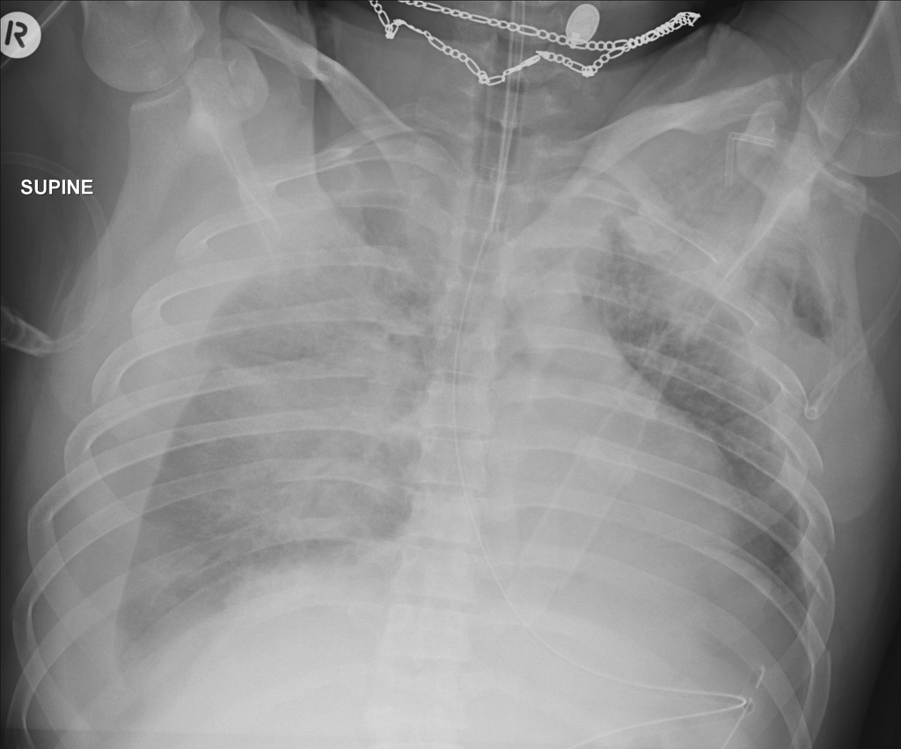  Case courtesy of Dr Andrew Dixon, https://radiopaedia.org/  From the case https://radiopaedia.org/cases/31573 rID: 31573 | 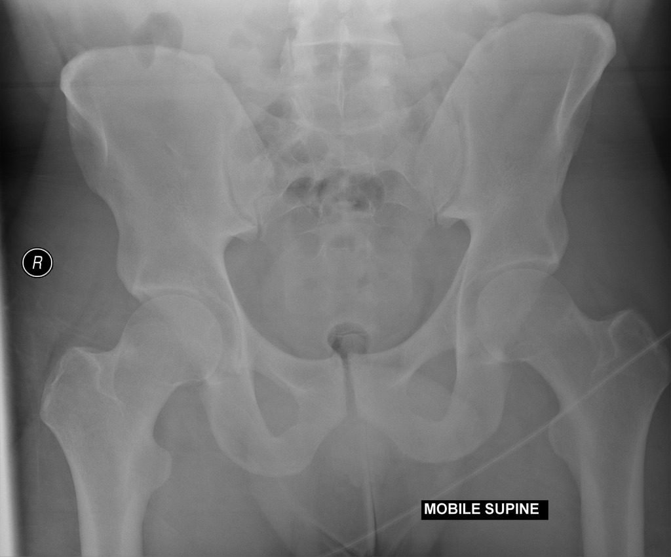  Case courtesy of Dr Craig Hacking, https://radiopaedia.org/  From the case https://radiopaedia.org/cases/41751 rID: 41751
Ultrasound Video Files (if applicable)
Negative FAST |  | Chest ultrasound confirms right-sided hemopneumothorax

Section VIII: Debriefing Guide

General Debriefing Plan
Individual |  | Group | With Video | Without Video
Learning Goals & Objectives
Educational Goal: | To challenge learners’ teamwork and communication skills through the stabilization of an unstable trauma patient
CRM Objectives: | - To practice effective leadership and followership in a clinical team  - To use best practices in team communication, including closed loop communication and periodic summaries  - To perform critical procedures during a resuscitation without losing situational awareness
Medical Objectives: | - To recognize respiratory failure in a blunt trauma patient and initiate simultaneous treatment and diagnostics  - To safely intubate an unstable trauma patient  - To identify and expediently treat a large hemothorax  - To identify and treat decompensated hemorrhagic shock
Sample Questions for Debriefing
CRM
- What communication challenges were present during this patient encounter? What tools did you use to overcome them?
- What steps did you use to prepare the team for the specific tasks (intubation, chest tube) that were required for this patient?
- What is your strategy for maintaining awareness of the whole patient while specific tasks are being performed?
Medical Expert
- Describe your differential diagnosis for respiratory failure in a trauma patient? How did you work through this in this patient?
- What are the indications for intubation in a trauma patient? What was the indication in this patient?
- Outline an approach to intubation of the trauma patient.
- What is the clinical evidence for hemorrhagic shock? What is the difference between compensated and decompensated shock?
Key Moments
Conducting a primary survey
Preparing the team for intubation and chest tube placement
Recognizing hemorrhagic shock and ordering blood products

